
Technical Coding Research Innovation, Navi Mumbai,
Maharashtra, India-410206

Build out AWS service architecture for Enterprise retail store with following assumptions: 1. 100+ stores 2. Inventory Management 3. Analytics services to be run by the stores.

Assignment Submitted for the requirement of
Technical Coding Research Innovation

For the Internship Project work done during

CLOUD COMPUTING USING AWS INTERNSHIP PROGRAM

by

Bishal Nandi : TCRIP01R38

Date: 3/01/2023 Rutuja Doiphode
CO-FOUNDER &CEO
TCR innovation.

` ▶ PROBLEM STATEMENT

Enterprise retail stores must run on Retail inventory management for ensuring we have enough inventories to meet customer demand so that we don't end up with too little or too much merchandise. It's essential if we’d like to avoid situations where we run out of popular items or end up with excess items that nobody is buying.

The manual inventory system involves a person manually maintaining and updating each record, increasing the risk of human error. Furthermore, this system is also susceptible to data loss because inventory sheets can get torn up over time, lost, or replaced. It’s also very tough to figure out which products are selling fast, which product needs more stock, and that manual operation lacks the analytic report.

So we are making a solution to this by taking the complete architecture on a cloud platform. We have used AWS as AWS (Amazon Web Services) provides a very efficient and cost-effective way of building scalable, reliable, and robust service architecture. It offers a wide range of powerful and easy-to-use services, like S3, SNS, SQS, Lambda, DynamoDB, etc.

▶ SOLUTION

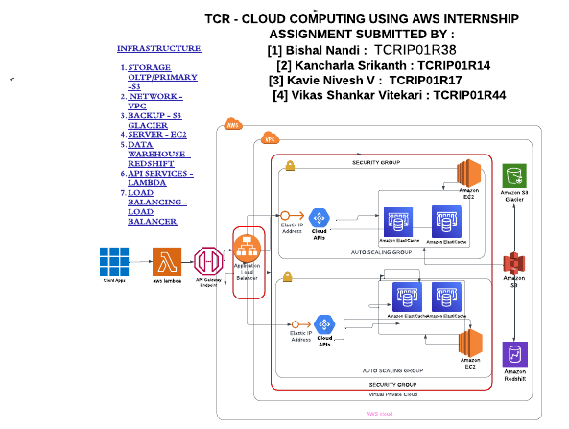
CTRL (+) LEFT CLICK HERE TO GET REDIRECTED TO LUCID CHART DIAGRAM > OR COPY&PASTE LINK TO BROWSER : https://lucid.app/lucidchart/125dca04-f092-42c6-8dcc-dd3be492277c/edit?viewport_loc=-1033%2C-1205%2C3341%2C1364%2C0_0&invitationId=inv_95bc10ed-2efd-4119-b525-a1e71cc23edd

Here we have setup API Gateways so that whenever the API wants to communicate with the EC2 instance for storing data or pulling data or other tasks it goes via gateway. The application of client will get connected to the API gateway and the API gateway will connect to the

cloud APIs and then finally the cloud API will get executed in the EC2 instance.

After that we have also implemented in security group and added the Application load balancers followed by Implementing Lambda which is connected with the end point gateway and the end point gateway is connected to the EC2 instance which is then connected with the S3 bucket.

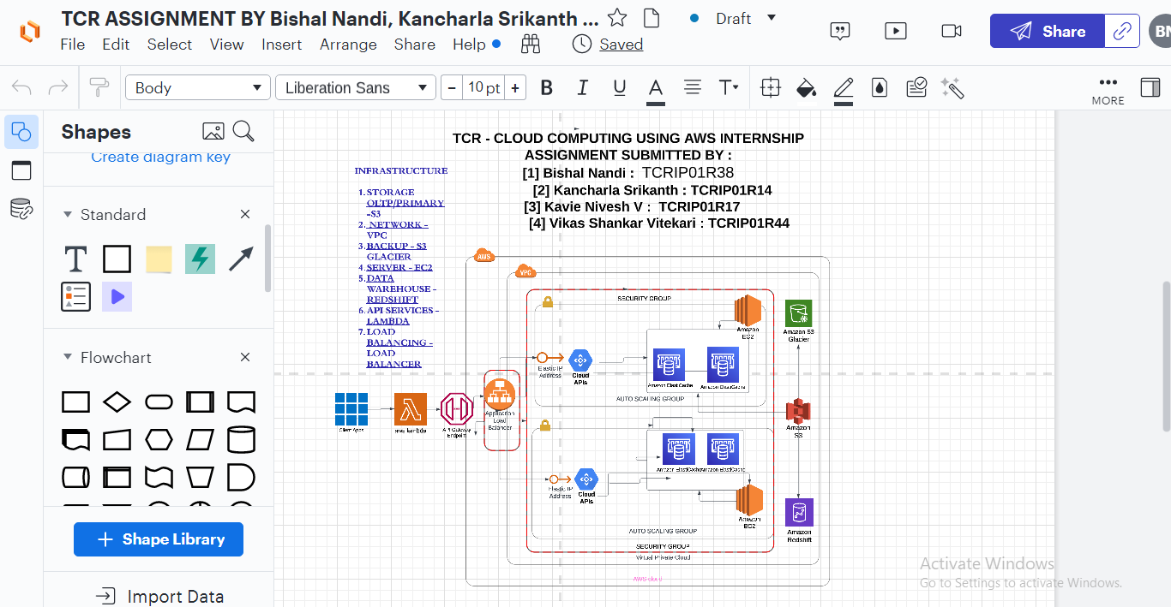

▶ OUTCOME

Allowing all the API requests would be dangerous as it might cause issue in security factor and Gateway provides a unified entry point across internal APIs. It allows us to control user access. And it enables security measures, like rate limiting, and applies security policies, like OAuth or JWT. An API gateway is especially important for securing micro services.

The load balancer is making use of the two different EC2 instances with two different security groups which distributes the network or application traffic across a number of servers which is increasing the capacity (concurrent users ) and reliability of the applications which ensures that no one server is overworked, which could degrade the performance.

The lambda is a server less, event-driven compute service that letting us run code for virtually any type of application or backend service without provisioning or managing servers. We can trigger Lambda from over 200 AWS services and software as a service (SaaS) applications.

And only pay for what we use which is reducing the cost and also it’s allowing developers to build and run services without having to manage the underlying infrastructure.

So to conclude the AWS service architecture for enterprise retail store will help in growth and tracking of the entire retail system. Since migrating to a server less architecture built on AWS—and with fully automated scaling—there’s a huge cut in its infrastructure costs and improved customers’ ticket-purchasing experience and also helped to innovate faster.

It will also track all the purchases and sells which will make it easier to stock the most sold good and other analytical calculations while keeping security in mind and prioritising it, we have also implemented highest security on the entire architecture.

*----------------*---------------*------------------*

THANKYOU
BISHAL NANDI: Certificate Code: TCRIP01R38

